Supplementary information for

**Contrasting depth distribution of colloid-associated phosphorus in the active and abandoned sections of an alluvial fan in a hyper-arid region of the Atacama Desert**

*Ghazal Moradiab⁎, Roland Bola, Luka Trbojevica, Anna Missonga, Ramona Mörchenc, Barbara Fuentesd, Simon M. Maye, Eva Lehndorffc, Erwin Klumppa*

a Agrosphere (IBG-3), Institute of Bio- and Geosciences, Forschungszentrum Jülich GmbH, Germany

b Institute for Environmental Research, Biology 5, RWTH Aachen University, Worringerweg 1, 52074 Aachen, Germany

c Institute of Crop Science and Resource Conservation - Soil Science and Soil Ecology, University of Bonn, 53115 Bonn, Germany

d Laboratorio de Tecnología de Membranas, Medio Ambiente y Biotecnología, Departamento de Ingeniería Química, Universidad Católica del Norte, Antofagasta, Chile

e Institute of Geography, University Cologne, Albertus-Magnus-Platz, 50923 Cologne, Germany

**\* Corresponding author:** Ghazal Moradi, [g.moradi@fz-juelich.de](mailto:g.moradi@fz-juelich.de), Tel: +49 (0)2461613521

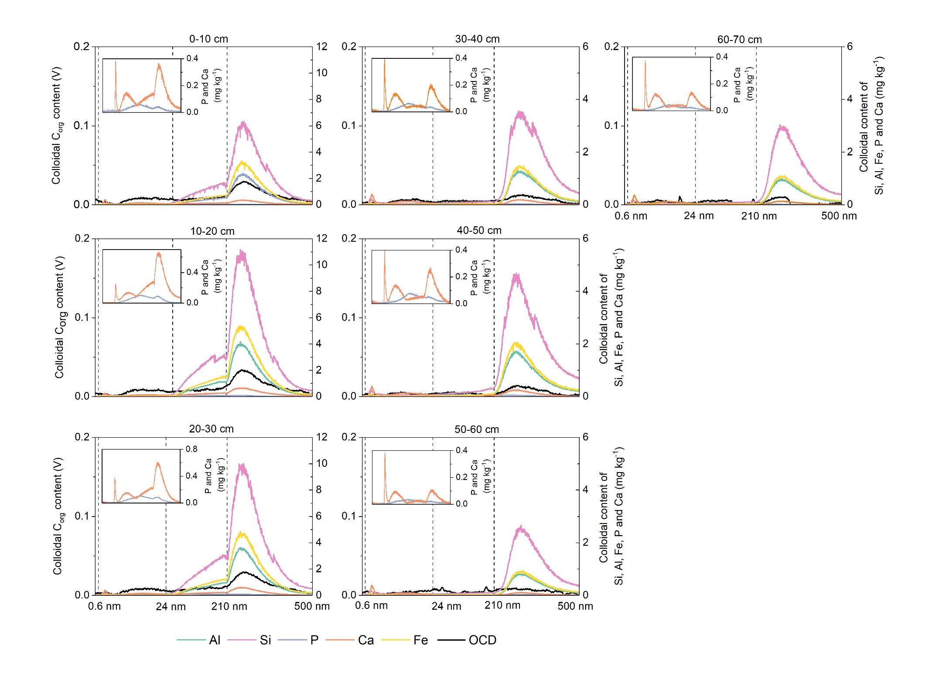

**Fig. S1-** ICPMS-AF4 and OCD-AF4 fractograms of all the samples from the Pap1450-Fan.

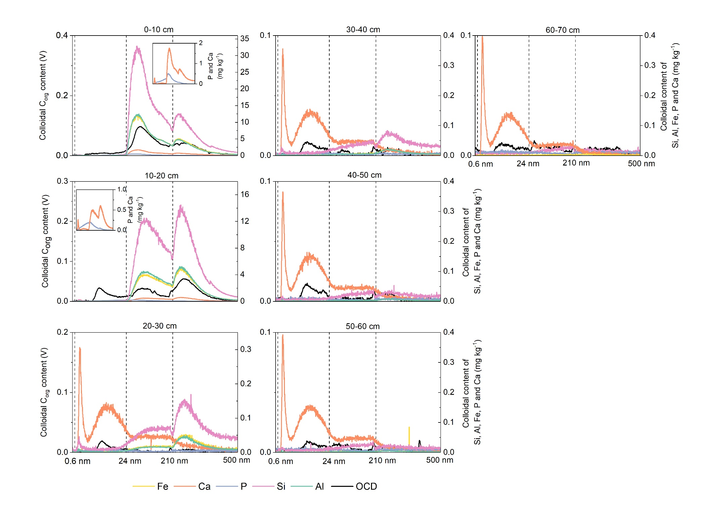

**Fig. S2-** ICPMS-AF4 and OCD-AF4 fractograms of all the samples from the Pap1450-Crust.

**Table S1-** *characteristics of the samples, and element content of WDCs in mg kg-1 dry soil. The average of WDCs is measured by offline DLS measurements. Element concentration of WDCs are calculated from the integrated peak areas of fractograms. Also, the elemental content of NP, FC and MC are given.*

|  |  |  |  |  |  |  |  |  |  |  |  |  |  |  |  |  |  |  |  |  |  |  |  |
| --- | --- | --- | --- | --- | --- | --- | --- | --- | --- | --- | --- | --- | --- | --- | --- | --- | --- | --- | --- | --- | --- | --- | --- |
| Profile | depth | pH | DLS | total OC⁎ | total P | Si | | | Fe | | | Al | | | P | | | Ca | | | OC | | |
|  |  |  |  |  | | |  | | |  | | |  | | |  | | |  | | |
| cm |  | nm | mg/kg | mg/kg | mg/kg | | | mg/kg | | | mg/kg | | | mg/kg | | | mg/kg | | | mg/kg | | |
|  |  |  |  |  |  | NP | FC | MC | NP | FC | MC | NP | FC | MC | NP | FC | MC | NP | FC | MC | NP | FC | MC |
| Pap1450-Crust | 0-10 | 8.3 | 296 | 450 | 1688 | 0.7 | 354.1 | 145.1 | 0.2 | 132.2 | 58.6 | 0.2 | 134.6 | 54.6 | 0.2 | 5.5 | 0.6 | 0.4 | 19.7 | 10.2 | 0.3 | 3.1 | 1.8 |
| 10-20 | 8.8 | 304 | 455 | 2511 | 0.6 | 163.9 | 155.8 | 0.2 | 53.7 | 54.1 | 0.1 | 59.5 | 56.8 | 0.1 | 2.5 | 0.4 | 0.4 | 7.4 | 9 | 0.7 | 1.1 | 2 |
| 20-30 | 8.6 | 341 | 495 | 1662 | 0.1 | 1.1 | 2.2 | 0 | 0.3 | 0.7 | 0 | 0.3 | 0.6 | 0 | 0.1 | 0.1 | 0.6 | 1.8 | 2.4 | 0 | 0.5 | 0.2 |
| 30-40 | 8.5 | 306 | 470 | 1525 | 0.6 | 1.6 | 46.7 | 0.2 | 0.5 | 17.6 | 0.1 | 0.2 | 15.5 | 0 | 0.8 | 0.6 | 0.7 | 2 | 5.7 | 0 | 0.3 | 0.2 |
| 40-50 | 8.5 | 300 | 460 | 1323 | 0 | 0.4 | 0.6 | 0 | 0.1 | 0.1 | 0 | 0.1 | 0.1 | 0 | 0.1 | 0.2 | 0.6 | 1.9 | 2.6 | 0 | 0.4 | 0.3 |
| 50-60 | 8.5 | 317 | 500 | 1345 | 0.5 | 1.4 | 32.5 | 0.2 | 0.4 | 11.6 | 0.1 | 0.2 | 10.1 | 0 | 0.4 | 0.4 | 0.6 | 1.5 | 4.3 | 0 | 0.4 | 0.3 |
| 60-70 | 8.5 | 311 | 495 | 1407 | 0 | 0.3 | 0.4 | 0 | 0 | 0.1 | 0 | 0 | 0.1 | 0.1 | 0.1 | 0.3 | 0.7 | 1.5 | 2.4 | 0 | 0.6 | 0.4 |
| Pap1450-Fan | 0-10 | 8.1 | 318 | 445 | 1428 | 0.5 | 16.5 | 72.5 | 0.2 | 7.2 | 35.5 | 0.1 | 5.2 | 26 | 0.1 | 0.8 | 0.5 | 0.4 | 1.7 | 4.3 | 0.4 | 0.3 | 1.3 |
| 10-20 | 8 | 352 | 605 | 1708 | 0.5 | 33.6 | 123.1 | 0.2 | 14.8 | 58.1 | 0.1 | 11.4 | 43.8 | 0 | 1.5 | 1 | 0.4 | 3.3 | 8.3 | 0.4 | 0.3 | 1.4 |
| 20-30 | 8.1 | 364 | 435 | 1586 | 0.6 | 28.8 | 112.6 | 0.2 | 11.8 | 52.3 | 0.1 | 9.1 | 39.6 | 0 | 1.5 | 1 | 0.6 | 4.2 | 10.8 | 0.3 | 0.4 | 1.3 |
| 30-40 | 8.1 | 412 | 415 | 178 | 0.6 | 1.6 | 46.7 | 0.2 | 0.5 | 17.6 | 0.1 | 0.2 | 15.5 | 0 | 0.8 | 0.6 | 0.7 | 2 | 5.7 | 0.2 | 0.2 | 0.6 |
| 40-50 | 8.1 | 415 | 415 | 1875 | 0.6 | 3 | 62 | 0.2 | 0.9 | 25.3 | 0.1 | 0.6 | 21.6 | 0 | 1.1 | 0.9 | 0.6 | 2.2 | 6.8 | 0.1 | 0.2 | 0.6 |
| 50-60 | 8 | 424 | 455 | 1552 | 0.5 | 1.4 | 32.5 | 0.2 | 0.4 | 11.6 | 0.1 | 0.2 | 10.1 | 0 | 0.4 | 0.4 | 0.6 | 1.5 | 4.3 | 0 | 0.3 | 0.6 |
| 60-70 | 7.6 | 398 | 405 | 1404 | 0.5 | 1.4 | 36.8 | 0.2 | 0.4 | 13.4 | 0.1 | 0.2 | 11.7 | 0 | 0.6 | 0.4 | 0.6 | 1.8 | 4.9 | 0.1 | 0.2 | 0.2 |

*⁎ Total OC content of bulk soils are taken from (Mörchen et al., 2019)*

**Table S2-** Parameters of the AF4 separation method.

|  |  |
| --- | --- |
| **Parameters** | |
| Detector flow | 0.5 mL min-1 |
| Injection volume | 500 µL |
| Spacer | 500 µm |
| Membrane | 1kDa PES |
| Carrier solution | 25 µM NaCl |
| Focus time | 6 min |
| Transition time | 0.5 min |
| Cross-flow t0 min – t6 min | 3 mL min-1 |
| Cross-flow t6 min – t6,5 min | 3 mL min-1 |
| Cross-flow t6,5 min – t10 min | 1.98 mL min-1 |
| Cross-flow t10 min – t17 min | 1 mL min-1 |
| Cross-flow t17 min – t20 min | 0.7 mL min-1 |
| Cross-flow t20 min – t26 min | 0.15 mL min-1 |
| Cross-flow t26 min – t35 min | 0.07 mL min-1 |
| Cross-flow t46 min – t111 min | 0 mL min-1 |

**Reference:**

Mörchen, R., Lehndorff, E., Diaz, F.A., Moradi, G., Bol, R., Fuentes, B., Klumpp, E., Amelung, W., 2019. Carbon accrual in the Atacama Desert. Global and Planetary Change 181, 102993. https://doi.org/10.1016/j.gloplacha.2019.102993